CSE 141L Project Report

David Hong A18506803, Alex Tatoian A18508705

# Academic Integrity

Your work will not be graded unless the signatures of all members of the group are present beneath the honor code.

To uphold academic integrity, students shall:

* Complete and submit academic work that is their own and that is an honest and fair representation of their knowledge and abilities at the time of submission.
* Know and follow the standards of CSE 141L and UCSD.

Please sign (type) your name(s) below the following statement:

I pledge to be fair to my classmates and instructors by completing all of my academic work with integrity. This means that I will respect the standards set by the instructor and institution, be responsible for the consequences of my choices, honestly represent my knowledge and abilities, and be a community member that others can trust to do the right thing even when no one is watching. I will always put learning before grades, and integrity before performance. I pledge to excel with integrity.

David Hong

Alexander Tatoian

# 0. Team

David Hong, Alexander Tatoian

# Introduction

Name your architecture. What is your overall philosophy? What specific goals did you strive to achieve? Can you classify your machine in any of the standard ways (e.g., stack machine, accumulator, register-register/load-store, register-memory)? If so, which? If not, devise a name for your class of machine. Word limit: 200 words.

The **Seki Architecture** is a specialized 8-bit Load-Store RISC processor designed with the philosophy of "Optimization through Constraint." While modeled after the familiar MIPS architecture, our primary goal was to adapt standard load-store mechanics to a strict 9-bit instruction width without sacrificing general-purpose register flexibility.

To achieve this, we minimized our opcode space to strictly 3 bits, ensuring exactly 6 bits remained for payloads: the minimum required to represent useful signed immediates (range -32 to +31) or address two registers. Any larger opcode would have rendered immediate operations functionality impossible. We overcame the remaining bit shortages by adopting implicit resource usage: we restricted complex operations like branching to specific registers (R0 or R1) and utilized R0 as an implicit offset accumulator for long-distance jumps.

We classify the Seki machine as a Load-Store Architecture with Hybrid Accumulator characteristics. While it primarily operates on general-purpose registers, the reliance on R0 for handling immediate offsets and jump targets mimics accumulator efficiency to satisfy the 9-bit constraint.

(163 words)

# Architectural Overview

This must be in picture form. What are the major building blocks you expect your processor to be made up of? You must have data memory in your architecture. (Example of MIPS: <https://www.researchgate.net/figure/The-MIPS-architecture_fig1_251924531>)

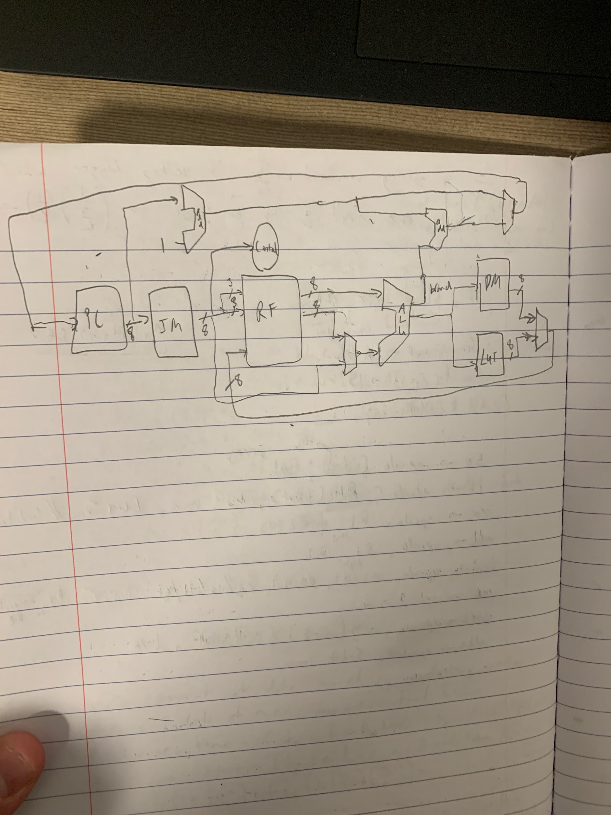

# Machine Specification

## Instruction formats

| **TYPE** | **FORMAT** | **CORRESPONDING INSTRUCTIONS** |
| --- | --- | --- |
| R | 3-bit opcode, 3-bit destination register, 3-bit destination register | ADD, ANDB, XOR |
| S | 3-bit opcode, 1-bit instruction selector, 2-bit operand register, 3-bit destination register | SHL, SHR |
| B | 3-bit opcode, 2-bit instruction selector, 1-bit operand register, 3-bit destination register | BEQ, BLT, LB, SB, START, DONE |
| I | 3-bit opcode, 6-bit signed immediate | ADDI, JUMP |

## Operations

| **NAME** | **TYPE** | **BIT BREAKDOWN** | **EXAMPLE** | **NOTES** |
| --- | --- | --- | --- | --- |
| ADD = register add operation | R | opcode: 3’b111  Rs: 3-bit (R0-R7)  Rd: 3-bit (R0-R7) | #Let R3 have 8’d38  #Let R2 have 8’d4  ADD $3, $2  -> This means R3 now have value 8’d42 | ADD Rd, Rs which will do: Rd += Rs |
| ANDB = 1-bit and operation | R | opcode: 3’b110  Rs: 3-bit (R0-R7)  Rd: 3-bit (R0-R7) | #Let R1 have 8’b0011 0110  #Let R6 have 8’b1111 0001  ANDB $1, $6  -> This means R1 will have keep its value:  8’b0011 0110 | ANDB Rd, Rs which will do: Rd &= Rs[0]  Where we do a bitwise AND with Rd against the LSB of Rs. In the example, if the LSB of R6 was 0, R1 would have become 8’d0 |
| XOR =  standard  XOR operation | R | opcode: 3’b101  Rs: 3-bit (R0-R7)  Rd: 3-bit (R0-R7) | #Let R4 have 8’b1111 0000  #Let R2 have 8’b1010 1010  XOR $4, $2  -> This means R4 will have value: 8’b0101 1010 | XOR Rd, Rs which will do: Rd ^= Rs  We will be using this to make a register 0 and also for our computation portion of program 1 |
| SHL =  standard shift left operation | S | opcode: 3’b100  instruction bit: 1’b0  Rs = 2-bit (R0-R4)  Rd = 3-bit (R0-R7) | #Let R7 have 8’b1010 1111  #Let R0 have 8’b1100 1100  SHL $7, $0  ->This means that R7 will have value: 8’b1111 0000 | This instruction takes the 3 LSBs from Rs (Rs[2:0]) as the shift amount. In the example, we shift by 3’b100 (shift left by 4). |
| SHR =  standard logical shift right | S | opcode: 3’b100  instruction bit: 1’b1  Rs = 2-bit (R0-R4)  Rd = 3-bit (R0-R7) | #Let R7 have 8’b1010 1111  #Let R0 have 8’b1100 1100  SHL $7, $0  ->This means that R7 will have value: 8’b0000 1010 | This instruction takes the 3 LSBs from Rs (Rs[2:0]) as the shift amount. In the example, we shift by 3’b100 (shift right by 4). |
| BEQ = branch equals | B | opcode: 3’b010  instruction bits: 2’b00  Rs = 1-bit (R0-R1)  Rd = 3-bit (R0-R7) | #Let R5 have 8'b0011 0101  #Let R1 have 8'b0011 0101  BEQ $5, $1  ->Since R5 = R1, our program counter will go to PC + 2 instead of PC + 1 | This instruction checks if  Rd = Rs. If they are equal we skip the next instruction. If they are not, we go to the next instruction. We will use our jump instruction to make a much larger jump than a single instruction. This will be the same for the other BLT and BOV. |
| BLT =  branch less than | B | opcode: 3’b010  instruction bits: 2’b01  Rs = 1-bit (R0-R1)  Rd = 3-bit (R0-R7) | #Let R5 have 8'b0011 0101  #Let R1 have 8'b0111 0101  BEQ $5, $1  ->Since R5 < R1, our program counter will go to PC + 2 instead of PC + 1 | Checks if Rd < Rs. Follows the same protocol as BEQ above. |
| BOV = branch overflow | B | opcode: 3’b010  instruction bits: 2’b10  Rs = 1-bit (R0-R1)  Rd = 3-bit (R0-R7) | #Let R5 have 8'b1011 0101  #Let R1 have 8'b0111 0101  BEQ $5, $1  ->Since R5 + R1 causes an overflow, our program counter will go to PC + 2 instead of PC + 1 | Checks if Rd + Rs causes an overflow. Follows the same protocol as BEQ above. |
| LBMEM = load byte from memory | B | opcode: 3’b011  instruction bits 2’b00  Rs = 1-bit (R0-R1)  Rd = 3-bit (R0-R7) | #Let R0 have 8’d42  LBMEM $3, $0  -> R3 will get the value of MEM[42] | Rd = MEM[Rs]. This will take from data memory |
| LBLUT = load byte from LUT | B | opcode: 3’b011  instruction bits 2’b01  Rs = 1-bit (R0-R1)  Rd = 3-bit (R0-R7) | #Let R0 have 8’b0001 0010  LBLUT $3, $0  -> R3 will get the value: 8’d0001 0001 | Rd[7:4] = LUT[Rs[7:4]]  Rd[3:0] = LUT[Rs[3:0]]  The LUT is a 4-bit LUT that stores the every 4-bit number’s hamming distances. |
| SBMEM = store byte from memory | B | opcode: 3’b011  instruction bits 2’b10  Rs = 1-bit (R0-R1)  Rd = 3-bit (R0-R7) | #Let R5 have 8’d42  #Let R1 have 8’d16  SBMEM $5, $1  -> MEM[16] = 42 now | MEM[Rs] = Rd. |
| DONE = program done | B | opcode: 3’b011  instruction bits 2’b11  Rs = 1’b0  Rd = 3’b000 | DONE  ->will end the program | Will end the program running; signifies the end of the program. |
| ADDI = add immediate operation | I | opcode: 3’b000  signed immediate: 6-bit (-32 to 31) | #Let R0 have 8’d11  ADDI 0d31  -> R0 will now have the value 8’d42 | R0 += immediate (signed). Our immediate can also be hex or binary, ex:  0b01 0101  0x2f |
| JUMP = jump up/down | I | opcode: 3’b001  signed immediate: 6-bit (-32 to 31) | #Let R0 have 8’d11  JUMP 0d31  -> We will jump: PC + 1 + 8’d42 | Jump amount: R0 += immediate (signed). Our immediate can also be hex or binary, ex:  0b01 0101  0x2f |

## Internal Operands

How many registers are supported? Is there anything special about any of the registers (e.g. constant, accumulator), or all of them general purpose?

The Seki Architecture supports 8 General-Purpose Registers (GPRs), denoted as R0 through R7. While all eight registers function identically for standard R-Type arithmetic (ADD, XOR, AND), specific registers have been assigned implicit roles to maximize functionality within the 9-bit constraint:

* R0 is the designated implicit target for all Immediate instructions (e.g., ADDI). Furthermore, it serves as the dynamic offset register for JUMP instructions, allowing the program to reach addresses beyond the immediate field's range.
* R0-R3: Shift operations are restricted to this subset to save opcode bits.
* R0 & R1: Conditional branches are restricted to testing only these two registers to preserve instruction density.

## Control Flow (branches)

What types of branches are supported? How are the target addresses calculated? What is the maximum branch distance supported? How do you accommodate large jumps?

We support three conditional branch types based on ALU flags: Branch Equal (BEQ) (checks Zero flag), Branch Less Than (BLT) (checks Sign flag), and Branch Overflow (BOV). Target addresses are calculated using PC-relative addressing. The JUMP and Branch instructions carry a 6-bit signed immediate, supporting a direct branch distance of -32 to +31 lines relative to the current PC. To accommodate control flow spanning the entire instruction memory (up to 4096 lines), we utilize a Register-Assisted Jump mechanism. The target is calculated as PC + 1 + R0 + Immediate. By pre-loading a large offset into R0 (using ADDI), we can jump to any location in memory without requiring multiple cascaded jump instructions.

## Addressing Modes

What memory addressing modes are supported, e.g. direct, indirect? How are addresses calculated? Give examples.

The Seki Architecture primarily supports Register Indirect Addressing. The Effective Address (EA) is simply the 8-bit value contained within the specified Source Register (Rs). There is no immediate offset addition during the memory stage; the address is taken "as-is" from the register. Since the registers and data path are 8-bits wide, the architecture supports a data memory space of 256 bytes (addresses 0x00 to 0xFF).

Example: Consider the instruction LBMEM $1, $2 (Load Byte from Memory):

* If R2 contains the value 0x0F
* The processor uses 0x0F as the memory address.
* The value stored at Data Memory address 0x0F is loaded into destination register R1.

# Programmer's Model [Lite]

4.1 How should a programmer think about how your machine operates? Provide a description of the general strategy a programmer should use to write programs with your machine. For example, one could say that the programmer should prioritize loading in the necessary values from memory into as many registers as possible, then perform calculations. Another approach could be loading and writing to memory in between every calculation step. Word limit: 200 words.

Programmers should adopt a Load-Execute-Store strategy, maximizing the use of registers R1–R7 for variable storage to minimize expensive memory access. However, the central strategic requirement is the careful management of Register R0. Because R0 acts as the implicit target for all immediate operations (constants) and the dynamic offset for long-distance jumps, it must be treated as a volatile accumulator. A programmer should generally avoid storing persistent data in R0, reserving it strictly for calculating constants, loop counters, and jump targets. Since the ISA is reduced to fit the 9-bit width, complex operations must be built from primitives. For example, since there is no SUBI (subtract immediate), a programmer must synthesize it using XOR (to invert) followed by an ADD. Code locality is critical as well; keeping loop bodies within 32 instructions avoids the extra cycle overhead required to set up R0 for long-distance register-assisted jumps. (145 words)

4.2 Can we copy the instructions/operation from MIPS or ARM ISA? If no, explain why not? How did you overcome this or how do you deal with this in your current design? Word limit: 100 words.

We cannot directly copy MIPS or ARM instructions because they are designed for 32-bit (or larger) instruction widths, while our architecture is strictly constrained to 9 bits. Standard MIPS opcodes (6 bits) and register fields (5 bits) alone exceed our total width. We overcame this by creating a custom "compressed" ISA: we reduced the opcode to 3 bits, shrunk register identifiers to 3 bits (8 registers), and used implicit registers (like R0 for immediate accumulation) to eliminate operand fields entirely for certain instructions, fitting complex functionality into our narrow 9-bit window.

# Program Implementation

## Program 1 Pseudocode

uint8_t min = 8;

uint8_t max = 0;

uint8_t i = 0;

// Outer Loop

while (i < 15) {

uint8_t val_i = Mem[i]; // Load A[i] into R7

Mem[17] = i; // SPILL i: Save R3 to Mem[17] to free up register

uint8_t j = i + 1; // j = i + 1

// Inner Loop

while (j < 16) {

Mem[16] = j;

uint8_t val_j = Mem[j]; // Load A[j] into R1

// Calculate Hamming Distance

uint8_t xor_val = val_i ^ val_j;

uint8_t packed_count = HardwareLUT(xor_val);

// Shift and Add to combine the nibble counts

uint8_t upper_count = packed_count >> 4;

uint8_t lower_count = packed_count & 0x0F;

uint8_t dist = upper_count + lower_count;

// Update Min

if (dist < min) {

min = dist;

}

// Update Max

if (dist > max) {

max = dist;

}

// Restore Context for Inner Loop

j = Mem[16]; // RESTORE j from Mem[16]

j++;

}

// Restore Context for Outer Loop

i = Mem[17]; // RESTORE i from Mem[17]

i++;

}

// Final Writeback

// Overwrite the scratchpad locations (16/17) with results

Mem[16] = min;

Mem[17] = max;

## Program 1 Assembly Code

ADDI 0d8

ADD $4, $0 //R4 will store min (initially 8), R5 will store max,

XOR $1,$1 //outer loop R1 starts at 0 (i = 0), where R1 temp stores i

XOR $7, $7 //(OUTER LOOP JUMP HERE) ******************************

XOR $0, $0

XOR $1, $1

ADDI 0d15 //now R0 has 15

ADD $1, $0 //load 15 into R1

XOR $0, $0

ADDI 0d31

ADDI 0d31 //R0 has 62

BLT $3, $1 //we need to check i < 15

JUMP 0d-2 //go to line 74 (74-13-1=60) //JUMP OUT OF OUTER LOOP

XOR $1, $1

ADD $1, $3 //let R1 have i

LBMEM $7, $1 //R7 will store A[i]

XOR $0, $0

ADDI 0d17

SBMEM $3, $0 //store i in MEM[17], this will free up 2 registers when we store j in MEM

XOR $0, $0

XOR $2, $2

ADD $2, $3 //j = i

ADDI 0d1

ADD $2, $0 //R2 stores j= i+1

XOR $0, $0 //start of nest loop (INNER LOOP JUMP HERE) *************************************

XOR $1, $1 //zero out R1

ADDI 0d16

ADD $1, $0 //load 16 into R1

XOR $0, $0

ADDI 0d31 //load load

BLT $2, $1 //see if j < 16

JUMP 0d1 //jump to line 65 (65-32-1=32) //JUMP OUT OF INNER LOOP

SBMEM $2, $1 //store j in MEM[16]

XOR $0, $0

ADD $0, $2 //put j in R0

LBMEM $1, $0 //R1=A[j], now R7 = A[i] and R1 = A[j]

XOR $1, $7 //get xor val

LBLUT $1, $1 //get R1[7:4] = hamming[7:4] and hamming[3:0]

XOR $0, $0

ADDI 0d4 //shift amount in R0

XOR $2, $2

ADD $2, $1 //we will get the hamming distance of the upper (R2) and lower half (R1)

SHR $2, $0 //get top 4 bits

SHL $1, $0

SHR $1, $0 //this shift left and shift right elims the MSBs

ADD $1, $2 //now we get the final hamming distance in R1

XOR $0, $0 //prep for jump command

BLT $4, $1 //min < dist?

JUMP 0d1 //we want to replace min with dist (line 51&52)

JUMP 0d2 //just go to next comparison (go to next BLT) since min < dist

XOR $4, $4

ADD $4, $1

BLT $5, $1 //max < dist

JUMP 0d2 //if max >= dist don't do anything skip the reassignment

XOR $5, $5 //max < dist therefore we need to replace max

ADD $5, $1 //max = R1

XOR $0, $0

ADDI 0d16 //R0 = 16

LBMEM $2, $0 //load back in j into R2

XOR $0, $0

ADDI 0d1

ADD $2, $0 //j++

ADDI 0d-32 //R0 = -31

JUMP 0d-8 //go to line 25 (25-64-1=-40); start of inner loop

XOR $0, $0 //AFTER INNER LOOP JUMP HERE ******************************************************

ADDI 0d17

LBMEM $3, $0 //load i into 3

XOR $0, $0

ADDI 0d1

ADD $3, $0 // i++

ADDI 0d-32 //R0 = -31

ADDI 0d-32 //R0 = -63

JUMP 0d-7 //go to line 4 (4-73-1=-70); start of outer loop

XOR $0, $0 //AFTER OUTER LOOP JUMP HERE **************************************************

ADDI 0d16 //need to load $4 into MEM[16]

SBMEM $4, $0

ADDI 0d1 //need to load $5 into MEM[17]

SBMEM $5, $0

XOR $0, $0

XOR $0, $0 //not needed but will make sure everything writes before I terminate

DONE

## Program 2 Assembly Code

LBMEM $7, $0 //load first multiplicand

ADDI 0d1

LBMEM $6, $0 //load second multiplicand

ADD $1, $6

XOR $1, $7 //take the XOR, we are going to see if the XOR is signed (if the MSB is 1) and store that in mem

XOR $0, $0

ADDI 0d6 //r0 is 6

SBMEM $1, $0 //store that XOR quantity into mem[6]

ADDI 0d9 //we are trying to load 0xff into $1, so make r0 = 0xf

XOR $1, $1

ADD $1, $0

XOR $0, $0

ADDI 0d4 //this is our shift value

SHL $1, $0 //now we have R1 = 0xf0

ADDI 0d11 //R0 has 0xf again

ADD $1, $0 //now 0xff is loaded into R1

XOR $0, $0

ADDI 0d7

SBMEM $1, $0 //let's load 0xff into mem[7], will act as NOT in the future

ADD $5, $1 //let's keep 0xff while we can

XOR $1, $1

XOR $0, $0

BLT $7, $0 //see if $7 is negative

JUMP 0d3 //jump to line 28 (potentially flipping the sign of the next multiplicand)

XOR $7, $5 //if it is let's unsign it

ADDI 0d1

ADD $7, $0 //value in $7 got flipped

XOR $0, $0

BLT $6, $0 //see if $6 is negative

JUMP 0d3 //jump to line 34 (potentially flipping the sign of the next multiplicand)

XOR $6, $5 //if it is let's unsign it

ADDI 0d1

ADD $6, $0 //value in $7 got flipped

XOR $2, $2 //low product bits

XOR $3, $3 //high product bits

XOR $1, $1 //will use this to store i

XOR $4, $4 //need to load 7 into R4 for BLT statement LOOP STARTS HERE **********************************************

XOR $0, $0

ADDI 0d7

ADD $4, $0 //R5 has 7

XOR $1, $4

XOR $4, $1

XOR $1, $4 //switch R1 and R4 (i is in R4 now)

ADDI 0d31 //R0 now has 38

BLT $4, $1 // i < 7 ? only need to iterate 7 times because multiplicands are positive (MSB is 0)

JUMP 0d-5 //line 80 (80-46-1 = 33)

XOR $1, $4

XOR $4, $1

XOR $1, $4 //switch R1 and R4 again so i is in R1 again

XOR $4, $4 //zero out R4

ADD $4, $7 //R4 will be the temp holder of R7 for ANDB

ANDB $4, $6 //we see if R6[0] is 1, if it is R4 = R4, if not R4 = 0

XOR $0, $0

BEQ $4, $0 //is LSB of 4 = 0?

JUMP 0d1 //go to addition section

JUMP 0d17 // Jump to i++ (SKIP ADDITION SECTION since $4 is 0) line 65 (65-47-1=17)

SHL $4, $1 //$4 will have the bottom bits (need to shift left per iteration #)

XOR $0, $0

ADD $0, $4 // Copy R4 to R0 for BOV check

BOV $2, $0 // Check if R2 + R0 overflows

JUMP 0d3 // Skip carry logic (Jump over XOR, ADDI, ADD)

XOR $0, $0 // Clear R0 (Required for ADDI)

ADDI 0d1

ADD $3, $0 //add carryout from lower 8 to top 8

ADD $2, $4 //add shifted $4 into low bit

ANDB $4, $6 //do it again, we need this now for our high bit reg

XOR $0, $0

ADD $0, $1 // put i into R0 for ADDI ease

ADDI 0d-8 //R0 = i - 8

XOR $0, $5

ADDI 0d1 // R0 = -(i-8)= 8-i (our right shift amount!)

SHR $4, $0 //this will now go into our top 8 bits

ADD $3, $4

XOR $0, $0 //JUMP HERE IF ANDB results in 0 ******************************************

ADDI 0d1

ADD $1, $0 //i++

SHR $6, $0 //shift the 2nd multiplicand right

ADDI 0d-32 //R0 has -31

JUMP 0d-12 // JUMP BACK TO START OF LOOP line 37 (37-79-1=-43)

XOR $0, $0 // JUMP HERE After Done with loop *****************************************************

XOR $1, $1 //we now need to see if our final product needs to be turned negative or not (based on the XOR val from the start)

XOR $0, $0

ADDI 0d6

LBMEM $1, $0 //load the XOR value back

XOR $0, $0

BLT $1, $0 //test to see if the XOR < 0 (checking if sign bit is up)

JUMP 0d11 //if not signed go straight to mem writing (instr 98)

XOR $2, $5

XOR $3, $5 //flip bits of top and bottom bits

XOR $0, $0

ADDI 0d1

XOR $1, $1

ADD $1, $0

XOR $0, $0

BOV $2, $1 //see if it causes a cout

JUMP 0d1 //don't add cout (note )

ADD $3, $1 //add the cout if cout is caused in low bits

ADD $2, $1 //now the full number is correct

XOR $0, $0

ADDI 0d2

SBMEM $2, $0 //Mem[2] = R2

ADDI 0d1

SBMEM $3, $0 //Mem[3] = R3

XOR $0, $0

XOR $0, $0 //to make sure all is written to mem (takes up 2 more clock cycles)

DONE

## Program 3 Pseudocode

## Program 3 Assembly Code

LBMEM $7, $0 //load first multiplicand

ADDI 0d1

LBMEM $6, $0 //load second

ADDI 0d1

LBMEM $5, $0 //load third (for signage related stuff)

ADD $1, $6

XOR $1, $7 //take the XOR, we are going to see if the XOR is signed (if the MSB is 1) and store that in mem

XOR $1, $5 //take next XOR (- * - * - = -, but - * - * + = +)

XOR $0, $0

ADDI 0d6

SBMEM $1, $0 //store that XOR quantity into mem[6]

ADDI 0d8 //we are trying to load 0xff into $1

XOR $1, $1

ADD $1, $0

XOR $0, $0

ADDI 0d4 //this is our shift value

SHL $1, $0 //now we have R1 = 0xf0

ADDI 0d11 //R0 has 0xf again

ADD $1, $0 //now 0xff is loaded into R1

XOR $0, $0

ADDI 0d7

SBMEM $1, $0 //let's load 0xff into mem[7], will act as NOT in the future

ADD $5, $1 //let's keep 0xff while we can

XOR $1, $1

XOR $0, $0

BLT $7, $0 //see if $7 is negative

JUMP 0d4 //jump to line 28 (potentially flipping the sign of the next multiplicand)

XOR $7, $5 //if it is let's unsign it

ADDI 0d1

ADD $7, $0 //value in $7 got flipped

XOR $0, $0

BLT $6, $0 //see if $6 is negative

JUMP 0d7 //jump to line 38 (potentially flipping the sign of the next multiplicand)

XOR $6, $5 //if it is let's unsign it

ADD $6, $0 //value in $7 got flipped

XOR $1, $1 //will use this to store i

XOR $0, $0 //let's start the loop now (only need 7 iterations since MSB of second multiplicand is 0 guaranteed) ***************LOOP STARTS HERE

XOR $4, $4 //zero out R4

ADD $4, $7 //R4 will be the temp holder of R7 for ANDB

ANDB $4, $6 //we see if R6[0] is 1, if it is R4 = R4, if not R4 = 0

XOR $0, $0

BEQ $4, $0

JUMP 0d1

JUMP 0d17 // Jump to i++ (Skip the addition logic)

SHL $4, $1 //$4 will have the bottom bits (need to shift left per iteration #)

XOR $0, $0

ADD $0, $4 // Copy R4 to R0 for BOV check

BOV $2, $0 // Check if R2 + R0 overflows

JUMP 0d3 // Skip carry logic (Jump over XOR, ADDI, ADD)

XOR $0, $0 // Clear R0 (Required for ADDI)

ADDI 0d1

ADD $3, $0 //add carryout from lower 8 to top 8

ADD $2, $4 //add shifted $4 into low bit

ANDB $4, $6 //do it again, we need this now for our high bit reg

XOR $0, $0

ADD $0, $1 // put i into R0 for ADDI ease

ADDI 0d-8 //R0 = i - 8

XOR $0, $5

ADDI 0d1 // R0 = -(i-8)= 8-i (our right shift amount!)

SHR $4, $0 //this will now go into our top 8 bits

ADD $3, $4

XOR $0, $0 //JUMP HERE IF ANDB results in 0 **************************

ADDI 0d1

ADD $1, $0 //i++

SHR $6, $0 //shift the 2nd multiplicand right

XOR $4, $4

ADDI 0d6

ADD $4, $0 //R4 has val 7

XOR $0, $0

ADDI 0d-18 // Pre-load R0 with half the jump distance

ADDI 0d-18 // Pre-load R0 with the rest (-36 total)

BEQ $4, $1 // If i == 7, skip the jump (Fall through to exit)

JUMP 0d0 // Else, Jump PC + 1 + R0 (-36) -> Back to Loop Start

XOR $0, $0 // Clear R0 (since it was -36) before continuing

XOR $1, $1

ADD $1, $0

XOR $0, $0

BOV $2, $1 //see if it causes a cout

JUMP 0d1 //don't add cout (note )

ADD $3, $1 //add the cout if cout is caused in low bits

ADD $2, $1 //now the full number is correct

XOR $0, $0

ADDI 0d3

SBMEM $2, $0 //Mem[3] = R2

ADDI 0d1

SBMEM $3, $0 //Mem[4] = R3

//now we have to multiply part by part (Mem[3] by Mem[2] and then Mem[4] by Mem[2])

XOR $6, $6

ADDI 0d2

LBMEM $7, $0 //load first multiplicand

ADDI 0d1

LBMEM $6, $0 //load second multiplicand

// XOR $1, $1 //we now need to see if our final product needs to be turned negative or not (based on the XOR val from the start)

// XOR $0, $0

// ADDI 0d6

// LBMEM $1, $0 //load the XOR value back

// XOR $0, $0

// BLT $1, $0 //test to see if the XOR < 0 (checking if sign bit is up)

// JUMP 0d11 //if not signed go straight to mem writing (instr 83)

// XOR $2, $5

// XOR $3, $5 //flip bits of top and bottom

// XOR $0, $0

// ADDI 0d1

XOR $0, $0

XOR $0, $0 //to make sure all is written to mem (takes up 2 more clock cycles)

DONE

CSE 141L Milestone 3 Add-on Template

# Instructions

We are providing you with the template that should be copied and pasted into your Milestone 2 Report. The updated report, alongside your assembler, assembly, and machine code, will be your submission for Milestone 3.

# Individual Component Specification

## Top Level

Module file name: DUT.sv

### Functionality Description

Write a brief description of the functionality of this module.

* This module integrates the datapath and control unit, orchestrating the fetch-decode-execute-memory-writeback pipeline. Its functionality includes:
  + **Instruction Fetc**h: Uses the PC module to drive the address for the instr_mem, retrieving the current 9-bit instruction.
  + **Decoding & Control**: The controller decodes the opcode to generate all control signals (e.g., alu_op, reg_write, branch). Simultaneously, operand addresses (rs, rd) are decoded using multiplexers and extenders to handle the variable-width register fields of R, S, B, and I-type instructions.
  + **Register File Access**: Reads operands from and writes results back to the reg_file.
  + **Execution**: The ALU performs arithmetic, logical, and shift operations. For immediate instructions, the source operand is selected between a register and a sign-extended immediate.
  + **Memory Access**: The module interfaces with dat_mem for load/store operations and integrates a LUT (Lookup Table) for accelerated Hamming distance calculations.
  + **Next PC Logic**: It calculates the next program counter value, selecting between sequential execution (PC + 1) and branching/jumping (PC + 1 + offset) based on ALU flags and control signals.

### Schematic

Show us your schematic for the top level.

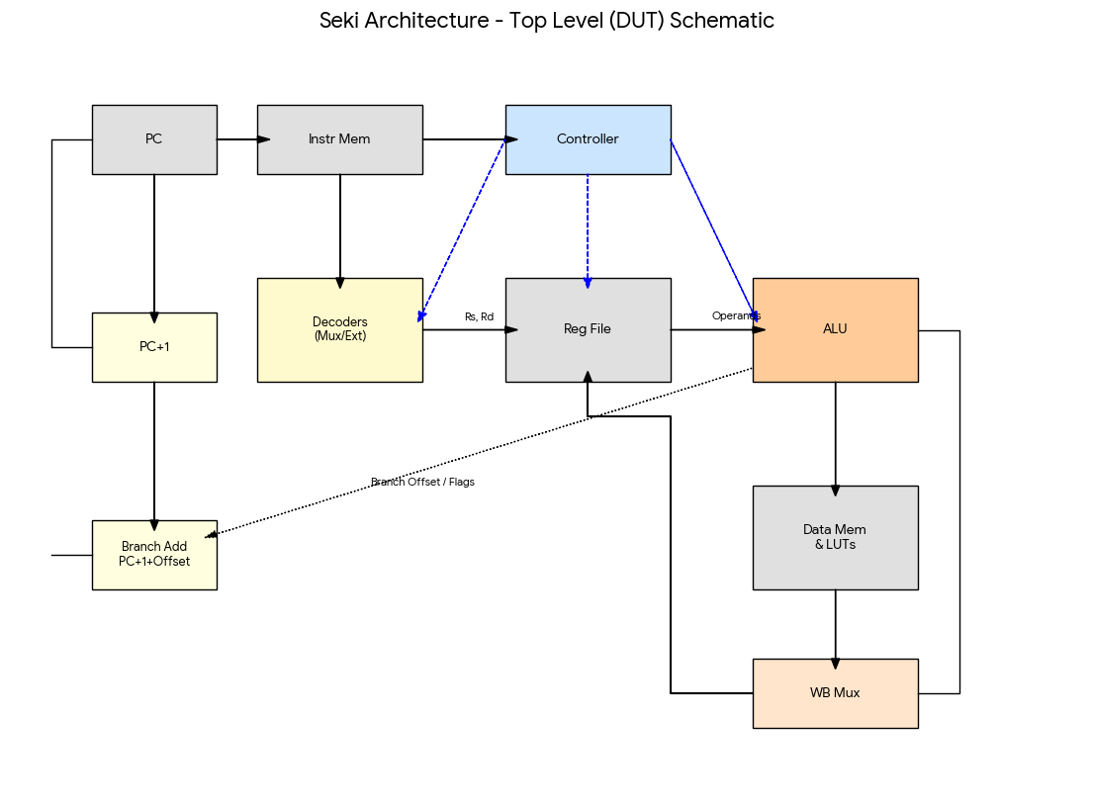

## Program Counter

Module file name: PC.sv

Module testbench file name: TODO

### Functionality Description

Write a brief description of the functionality of this module.

* The PC module is a 12-bit sequential register that stores the current instruction address for the processor.
  + Maintains a 12-bit internal register capable of addressing 4096 instructions.
  + On the rising edge of the clk, if the write enable signal wpc_en is high, the PC updates its value to the input in.
  + The current value is continuously output on out_val to drive the instruction memory address.

### (Optional) Testbench Description

TODO. Describe your testbench. How does it work? What test cases does it test?

### Schematic

Show us your schematic for the fetch unit.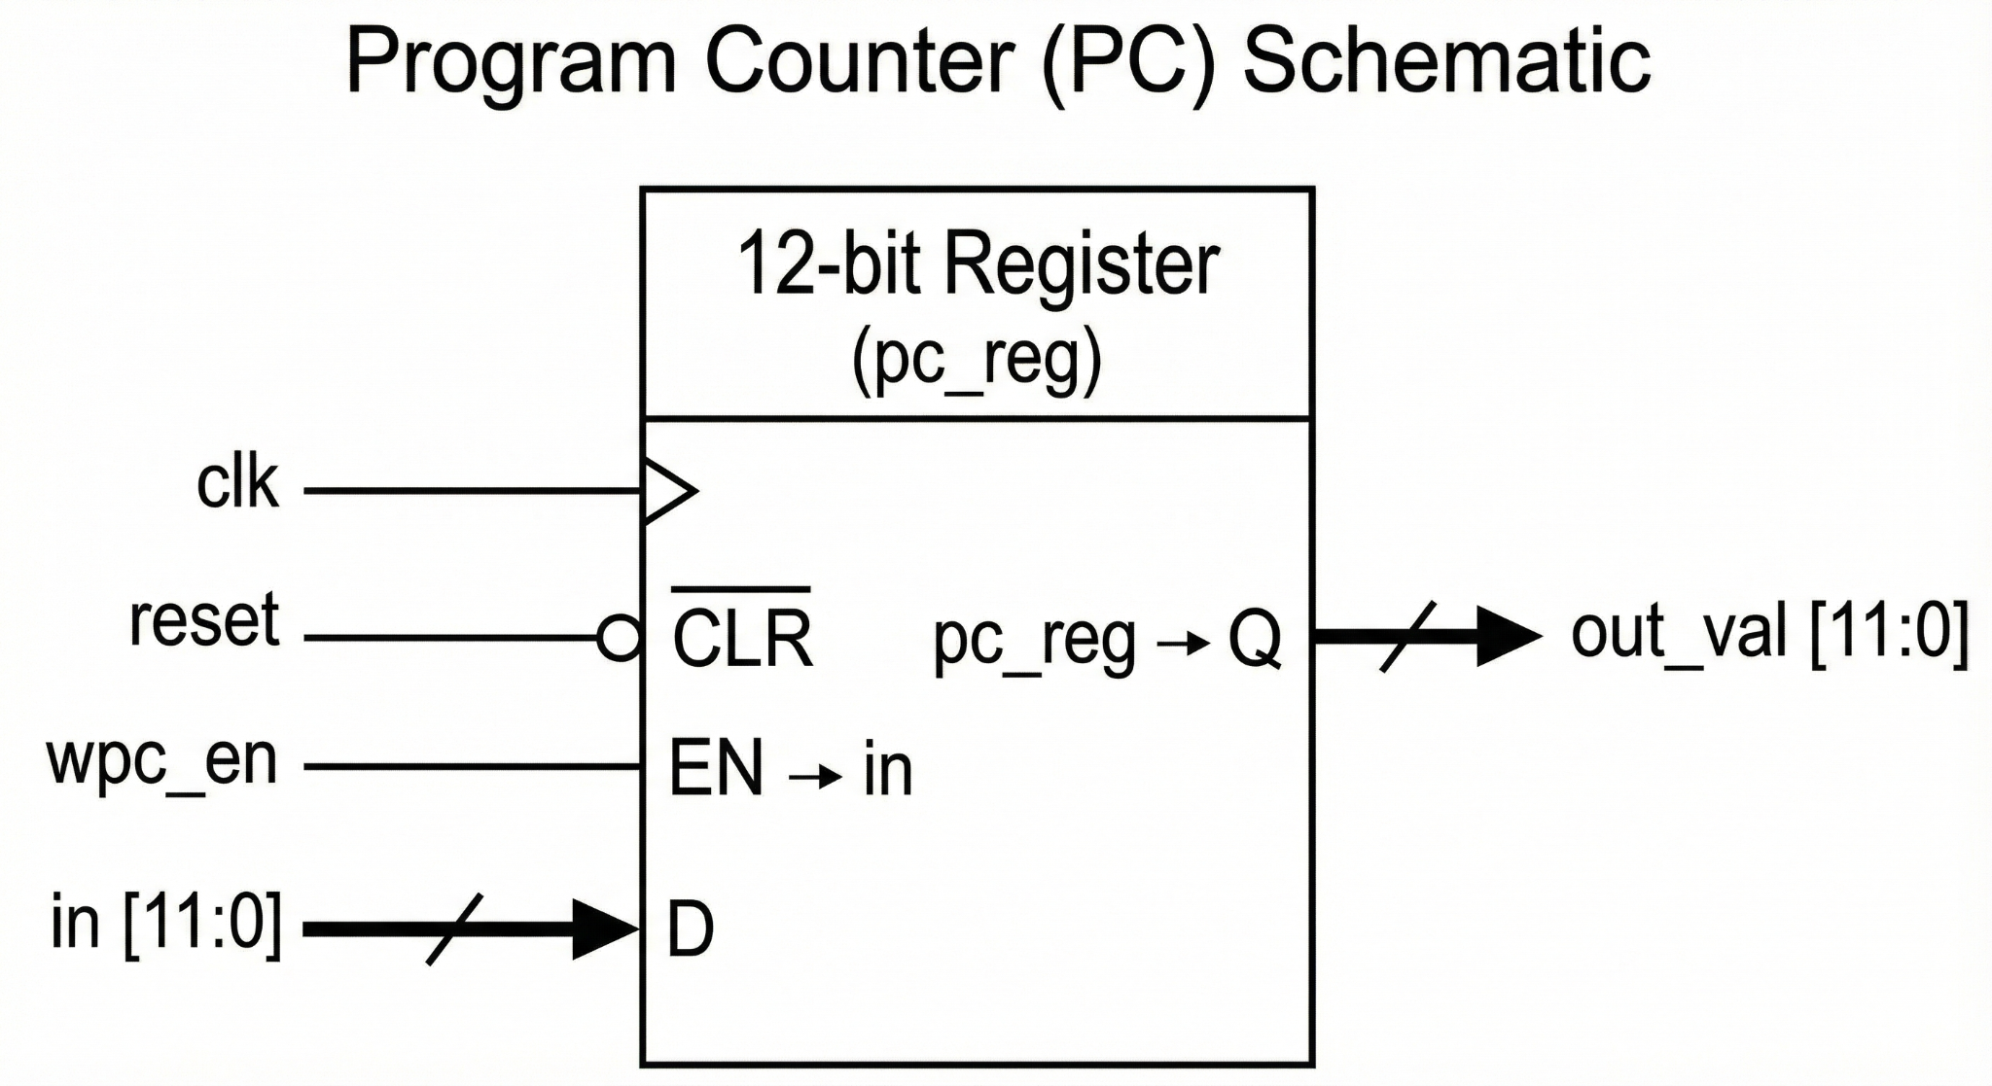

### (Optional) Timing Diagram

TODO. Show us a screenshot of the timing diagram that demonstrates all relevant functions of the fetch unit.

## Instruction Memory

Module file name: instr_mem.sv

### Functionality Description

Write a brief description of the functionality of this module.

* The instr_mem module is a read-only memory unit that stores the processor's program (machine code).
  + Contains 4096 memory locations, each holding a 9-bit instruction.
  + In simulation, this memory is initialized from an external file (e.g., machine_code.txt) using the $readmemb system task, loading the assembled program into the instr_core array

### Schematic

Show us your schematic for the fetch unit.

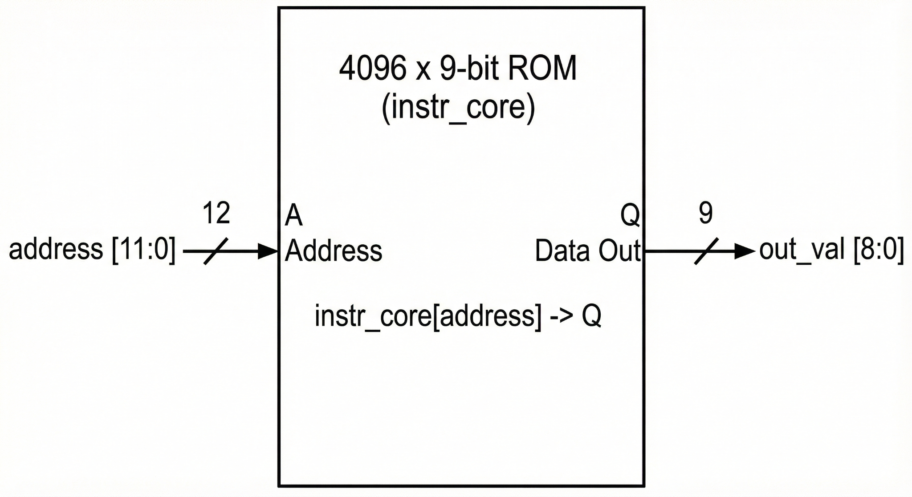

## Control Decoder

Module file name: controller.sv

### Functionality Description

Write a brief description of the functionality of this module.

* The controller module acts as the "brain" of the processor, translating the current instruction into control signals that orchestrate the datapath.
  + It receives the 3-bit opcode and 2-bit branch_bits (selectors) from the instruction, along with the system start signal.
  + Utilizing combinational logic (mostly case statements and assign logic), it determines the type of operation (R, I, S, or B-type) and asserts the appropriate control lines.
  + Then, it outputs register control, ALU control, memory control, branching, and the state (start/done).

### Schematic

Show us your schematic for the control decoder.

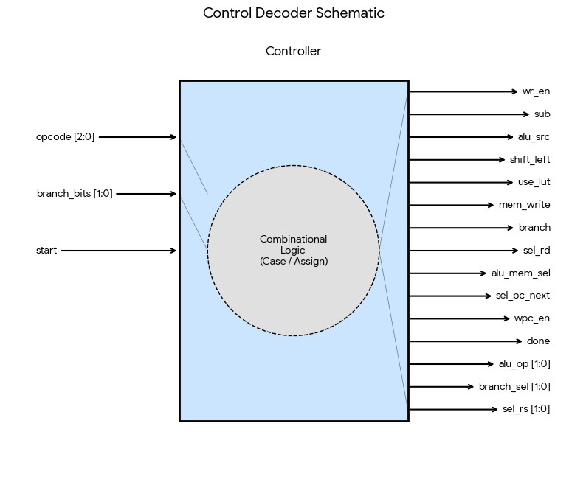

## Register File

Module file name: reg_file.sv

### Functionality Description

Write a brief description of the functionality of this module.

* **Functionality:** This module implements an 8-entry, 8-bit wide Dual-Port Read / Single-Port Write register file. It serves as the primary fast storage for the processor.
* **Storage**: Contains 8 general-purpose registers (R0–R7), each 8 bits wide.
* **Reading**: Supports asynchronous reading of two different registers simultaneously via read_addr1 and read_addr2. The values appear on read_val1 and read_val2 immediately when the addresses change.
* **Writing**: Supports synchronous writing to one register via write_addr. If write enable (wr_en) is high, the data on write_val is latched into the selected register on the rising edge of the clock (clk).
* **Reset**: Features an asynchronous reset which, when high, immediately clears all 8 registers to 0.

### Schematic

Show us your schematic for the register file.

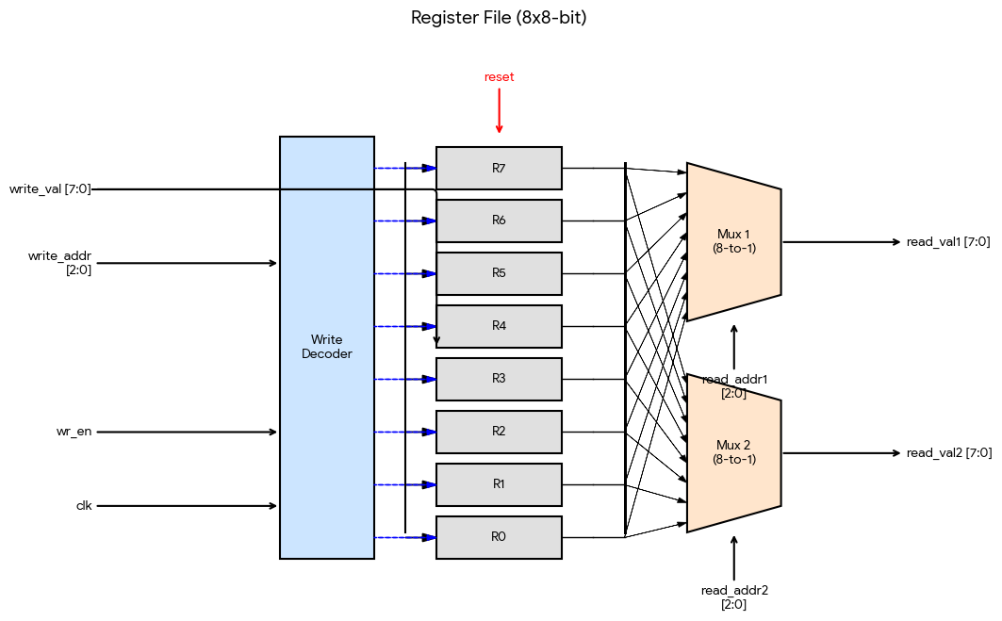

## ALU (Arithmetic Logic Unit)

Module file name: ALU.sv

Module testbench file name: tb_ALU.sv

### Functionality Description

Write a brief description of the functionality of this module.

* Responsible for performing all arithmetic, logical, and shift operations on 8-bit data.
  + **Arithmetic:** It performs 8-bit addition and subtraction. It utilizes a configurable 8-bit Full Adder (FA_8) where subtraction is achieved by inverting the second operand (~in2) and setting the carry-in (sub).
  + **Logic:** It executes bitwise XOR and a specialized "AND-Mask" operation (ANDB) where the first operand is masked by the LSB of the second operand.
  + **Shifting:** It performs logical Left (SHL) and Right (SHR) shifts via the Shifter submodule
  + **Branch Comparison:** It generates status flags (Zero, Sign, Overflow) based on subtraction results. A mux chain selects the specific flag required by the instruction (e.g., Equality, Less Than), zero-extends it, and outputs the result (1 for True, 0 for False) to be used by the Controller for Next-PC logic.

### (Optional) Testbench Description

TODO. Describe your testbench. How does it work? What test cases does it test?

### ALU Operations

What ALU operations will you be demonstrating? What instructions are they relevant to?

| ALU Op | Operation Name | Description | Relevance |
| --- | --- | --- | --- |
| 00 | ADD / SUB | Standard 8-bit Addition or Subtraction. | ADD, ADDI, LBMEM, SBMEM (Address calc) |
| 00 | BRANCH | Outputs a flag (Zero, Sign, or Overflow) based on a subtraction result. | BEQ (Zero), BLT (Sign), BOV (Overflow) |
| 01 | ANDB | Bitwise AND of in1 with the replicated LSB of in2. | ANDB |
| 10 | XOR | Bitwise Exclusive OR. | XOR |
| 11 | SHIFT | Logical Shift Left or Right (determined by shift_left). | SHL, SHR |

### Schematic

Show us your schematic for the register file.

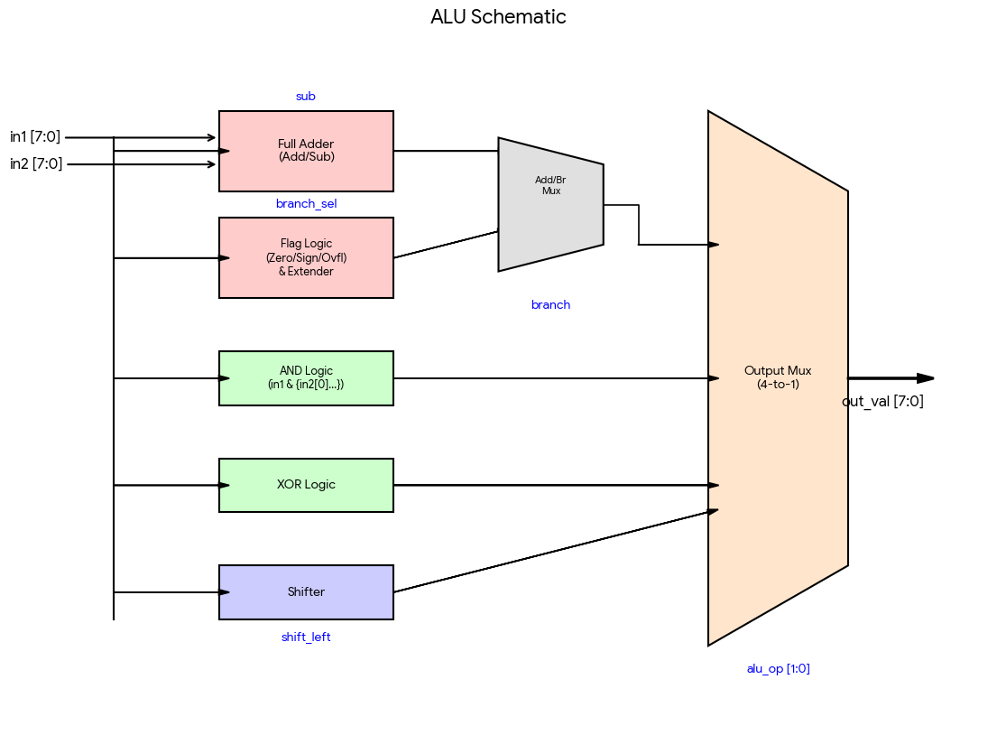

### (Optional) Timing Diagram

TODO. Show us a screenshot of the timing diagram that demonstrates all relevant operations you mentioned in the ALU Operations section.

## Data Memory

Module file name: dat_mem.sv

### Functionality Description

Write a brief description of the functionality of this module.

* This module provides 256 bytes of storage for the processor's runtime data.
  + Supports asynchronous read operations.
  + Supports synchronous write operations.

### Schematic

Show us your schematic for the data memory.

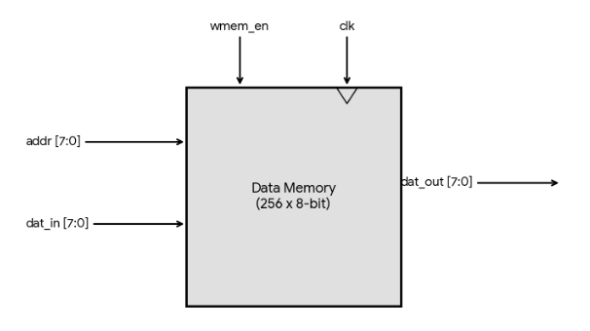

## Lookup Tables

Module file name: LUT_4.sv

### Functionality Description

Write a brief description of the functionality of this module.

* This module acts as a specialized hardware accelerator for calculating Hamming distance (population count) on 4-bit values.
  + It maps the input directly to the count of set bits (1s) in that 4-bit value using combinational logic.
  + In our architecture, two of these LUTs operate in parallel to calculate the Hamming distance of a full 8-bit byte in a single cycle (by splitting the byte into upper and lower nibbles).

### Schematic

Show us your schematic(s) for the lookup table(s).

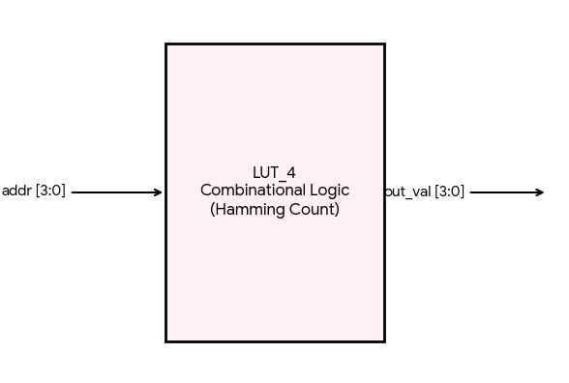

## Muxes (Multiplexers)

Module file name: mux_1.sv, mux_2.sv

### Functionality Description

Write a brief description of the functionality of this module.

* mux_1: This module is a parameterized 2-to-1 multiplexer. It takes two inputs (in0 and in1) of width DATA_WIDTH (default is 8 bits) and a single selection bit (sel).
* mux_2: This module is a parameterized 4-to-1 multiplexer constructed hierarchically using three instances of mux_1. It takes four inputs (in0 through in3) and a 2-bit selection signal (sel).

### Schematic

Show us your schematic for your mux(es).

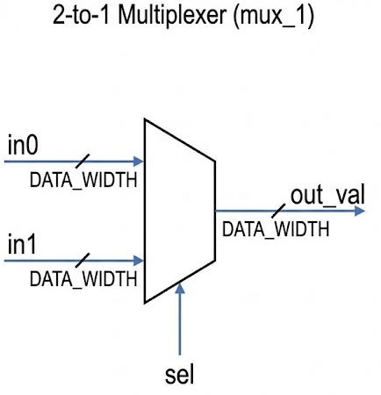

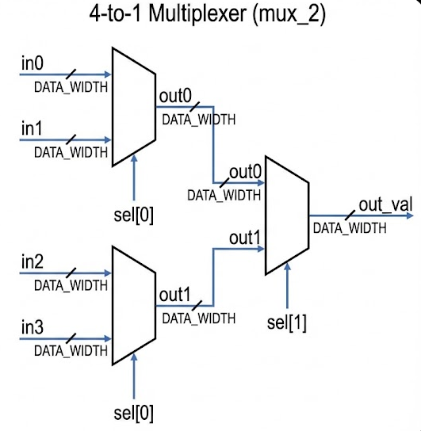

## Other Modules (if necessary)

Module file name: extender.sv

### Functionality Description

Write a brief description of the functionality of this module.

* This module is a parameterized unit designed to expand the bit-width of an input signal (in) to a larger output width (out_val). It supports two modes of extension, controlled by the is_sign_ext input: zero extension and sign extension:
  + Is_sign_ext = 0: The module pads the Most Significant Bits (MSBs) of the output with zeros.
  + is_sign_ext = 1: The module replicates the MSB (sign bit) of the input into the upper bits of the output. Preserves sign and value of signed two's complement numbers.

### Schematic

Show us your schematic for your module.

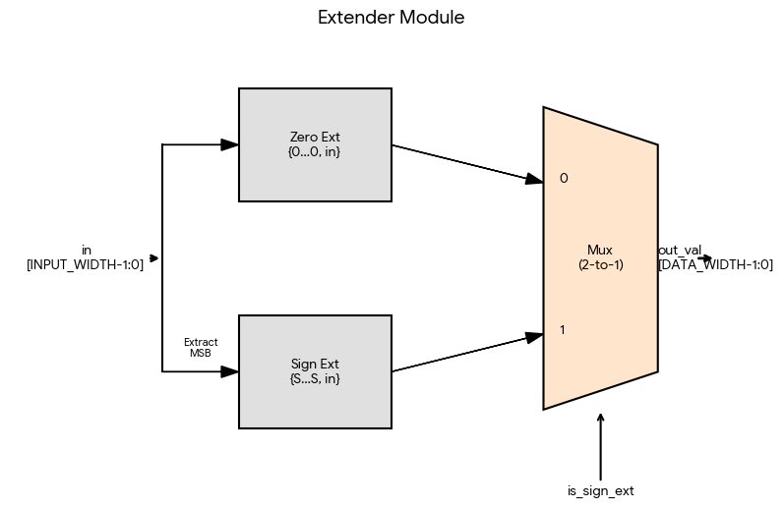

# Software – provide as attachments

Assembler

* Attached as assembler.py

Compiler, if you wrote one

* None.

Program 1,2,3 software strategies for your hardware

* Please refer to comments in the assembly scripts / our pseudo code

Program 1 assembly script

* prog1_asm.txt
* prog2_asm.txt
* prog3_asm.txt

Program 1,2,3 machine code

* prog1_mcode.txt
* prog2_mcode.txt
* prog3_mcode.txt

# Changelog

* Milestone 3 & Final Report
  + Introduction
  + Machine Specification
    - Fully defined our instruction formats and operations i.e the full ISA.
    - Added full details to Instruction formats, operations, internal operands, Control Flow, Addressing Modes
  + Programmer’s Model
    - Filled out full detail for how programmers should use our architecture and whether or not we can copy instructions from MIPS / ARM ISA.
  + Program Implementation
    - Created Program 1, 2 assembly code based on our initial pseudocode.
    - Created psuedocode for Program 3, and assembly code for Program 3 following our pseudocode.
  + Filled out description, functionality, and schematic for the individual components in detail. (Milestone 3 add ons)
* Milestone 2
  + We forgot to do Milestone 2; however addressed all parts in detail through milestone 3 and final report
* Milestone 1
  + Initial version